Networking hands on

ipconfig

ping google.com
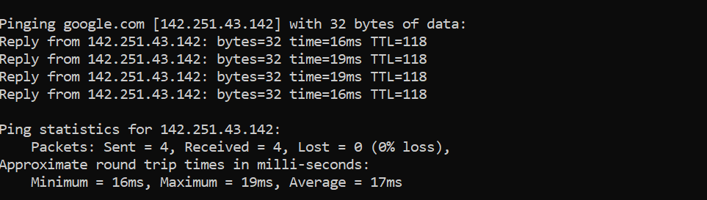

Traceroute to see path packets take-
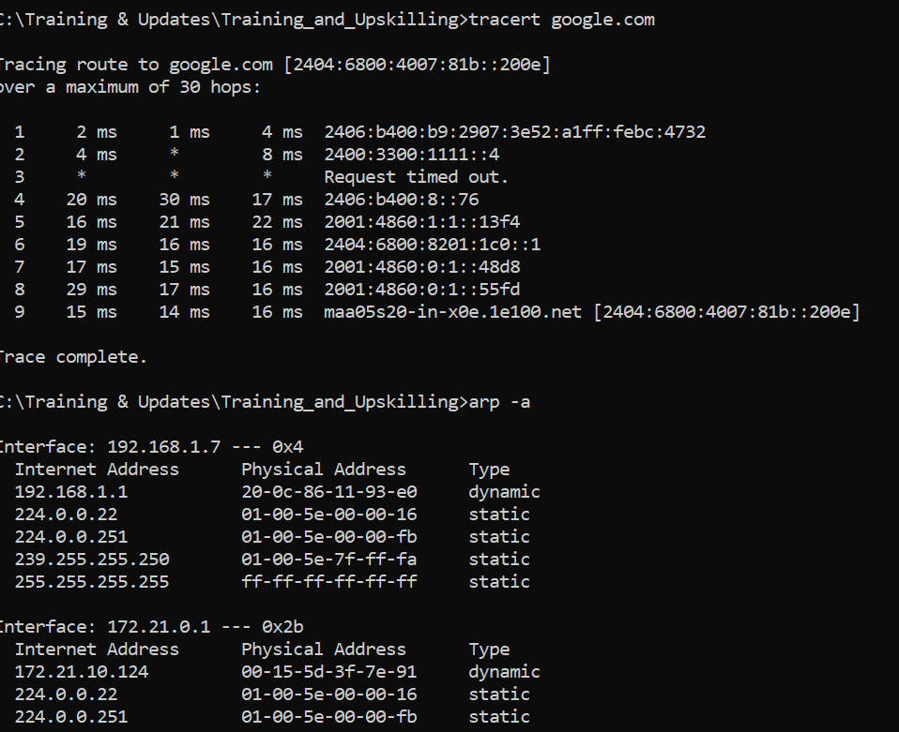
Address resolution protocol
Route print-
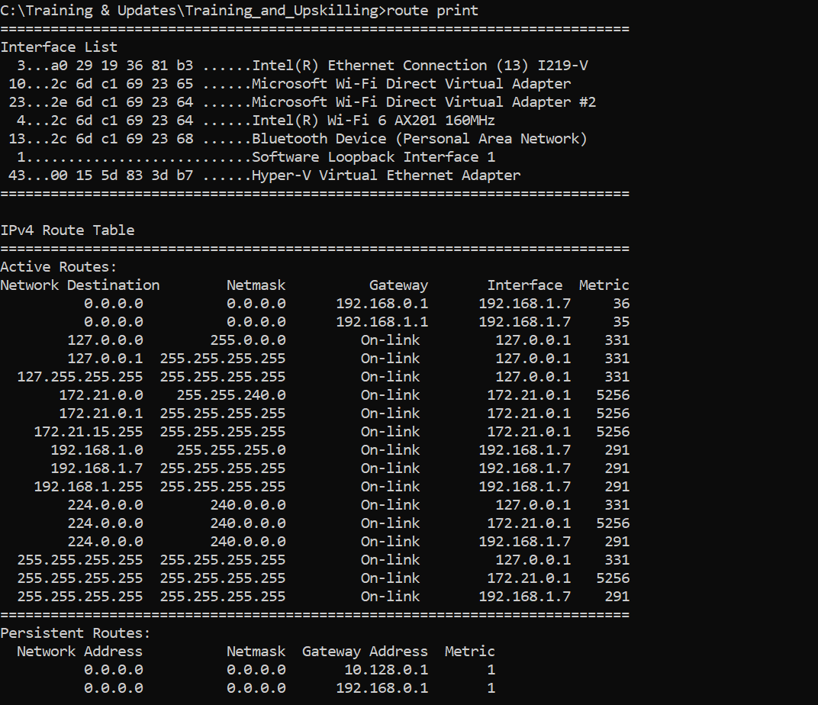
My local ping-
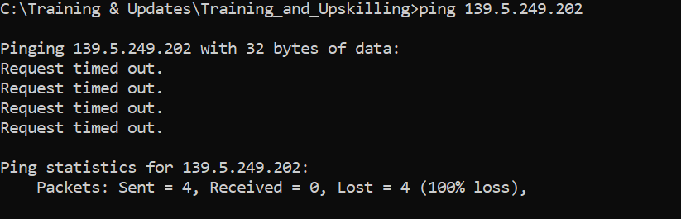

Nslookup-
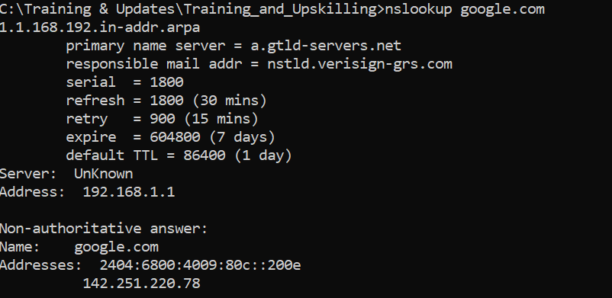

Active connection-
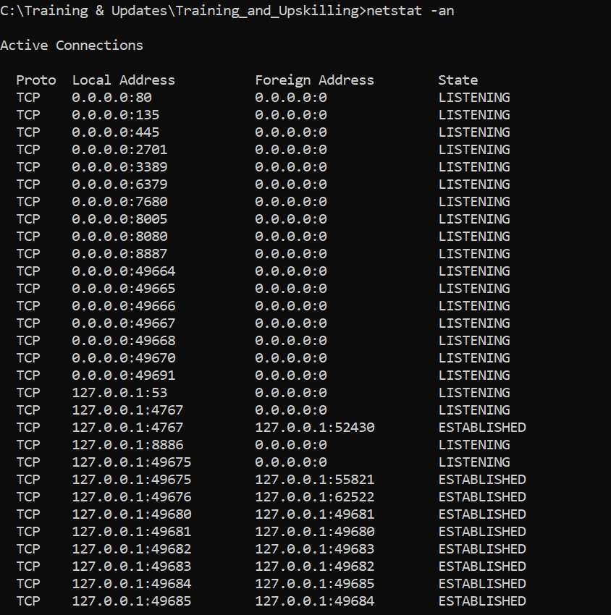

Firewall stats
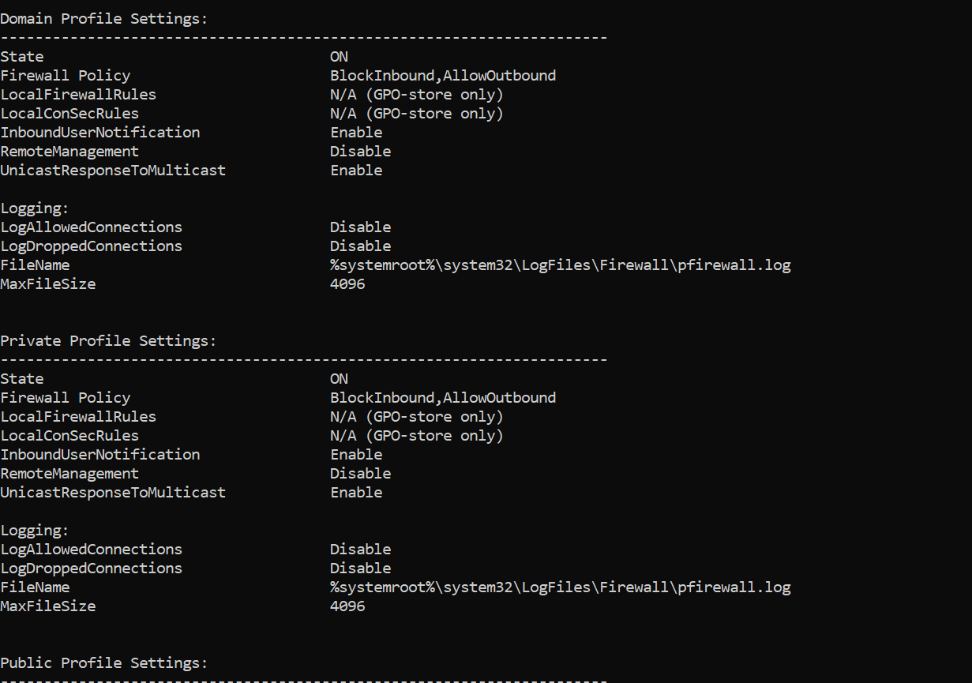
Few commands to use regularly-
Windows: ipconfig, ping, tracert, netstat, nslookup

Get mac-
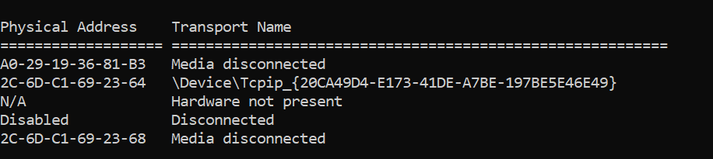

Open port on machine- netstat -an | find "LISTEN"

